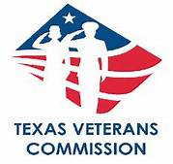

Veteran and Family Services Satisfaction Survey

TVC is implementing the "VFSSS" grantee customer survey to ensure that Veterans and their families receive quality customer service from our awarded organizations.

___________________________ ______________________________ ________________

Printed Name Signature Date

Veterans or Surviving Spouse? __________________________________

Has the TVC Veteran and Family Services Satisfaction Survey been completed? Yes or No

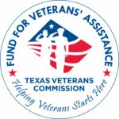This program is supported by a grant from the Texas Veterans Commission Fund for Veterans’ Assistance. The Fund for Veterans’ Assistance provides grants to organizations serving veterans and their families. For more information, visit www.tvc.texas.gov

Please provide your feedback

Scan the QR Code (https://www.surveymonkey.com/r/FVAGrantees)

